How to reverse engineer your competitors’ Google Ads strategy
Updated: October 12th, 2020
Execution Time: ~30 minutes


Goal: To reverse engineer your competitor’s Google Ads strategy.

Ideal Outcome: You have a standardized audit that shows you what your competitor is doing (including the exact ads they promote).

Prerequisites or requirements: You will need ahrefs, a paid tool (a $7 7-day trial is available for new users)

Why this is important: Your competitors (especially if he has been investing in ads for longer than you) might have been optimizing their Google Ads strategy for a while, and they might have strategies in place that you could apply yourself.

Where this is done: ahrefs and Google search.

When this is done: As soon as possible, ideally when you start your business or Google Ads. After that, you should be monitoring your competitor’s moves at least every month.

Who does this: The person responsible for Google Ads.

Analyze Your Competitors’ Google Ads Data

- Head over to Ahref’s Site Explorer and login to your account.
- Enter your competitor’s URL and click the search button.
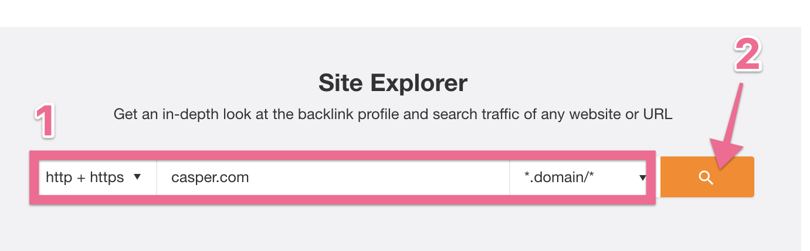

- Click “Paid Search”
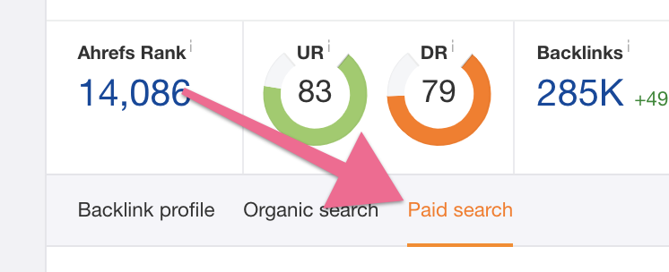
Note: If you get a ‘No Ads Found’ message, it means that your competitor is not running Google Ads or they started them very recently (less than a week ago) and ahrefs hasn’t been able to find them yet. If that is the case, there’s no need to proceed with this SOP.
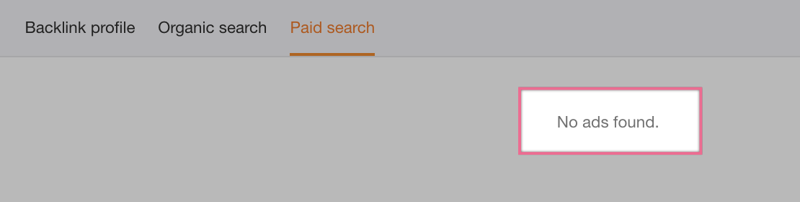

- You will get a general overview of what your competitor is doing on Google Ads. First, analyze the geo table on the right and select the country that you would like to analyze first. (You can go back to this step of the SOP as many times as you need later to run the same audit for different countries)

- Note: If you do not select a country, ahrefs will default it to the country with the largest volume.
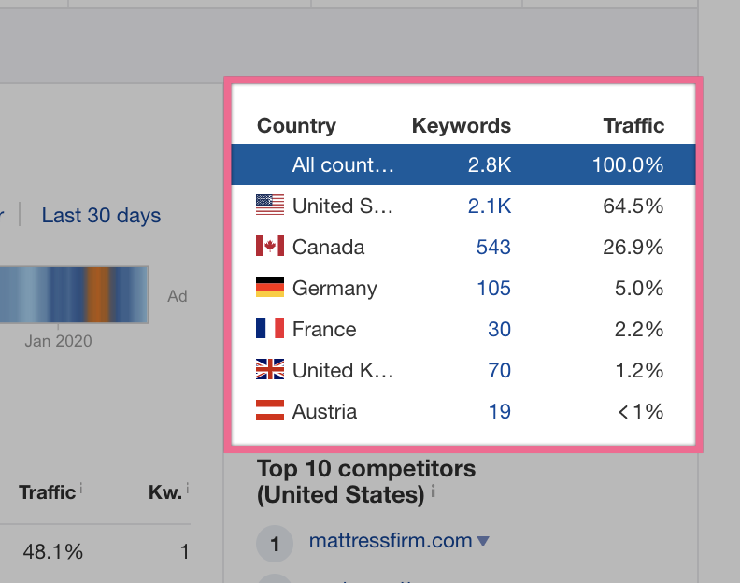

- Analyze the “PPC ads” heatmap to identify the periods in which your competitor might have invested more heavily in Google Ads.
  - Note: This heat map estimates the number of keywords your competitor was bidding in a given period. This does not necessarily mean they were investing more budget during the period, even though this will often be the case.
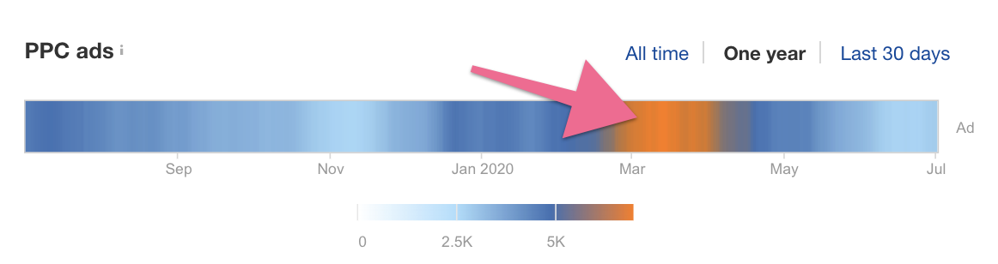

Analyze Your Competitors’ Keywords

- Select “PPC Keywords” on the sidebar
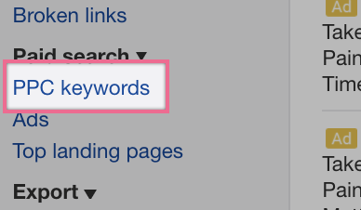
- You will get an estimated list of keywords your competitor is currently bidding for:
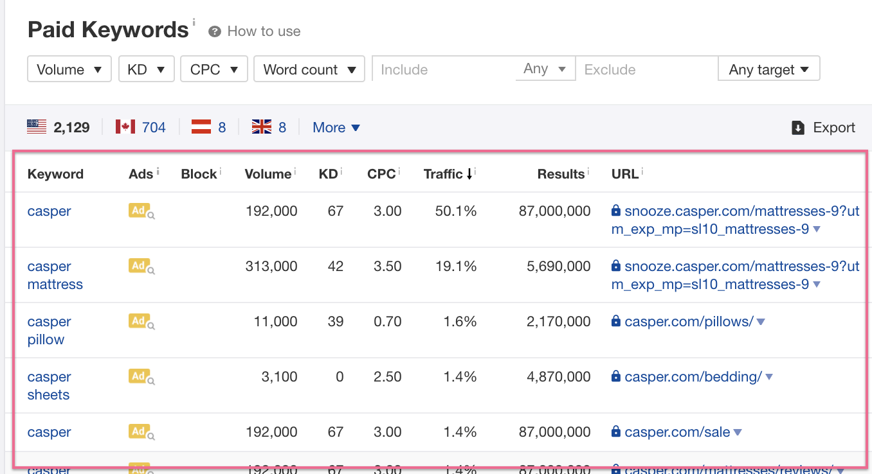

- To analyze the keywords that might be relevant to your business too, you will want to remove branded keywords from the list. To do that you will enter your competitor’s name in between asterisks in the ‘Exclude’ > ‘Keyword’ filter.
  - Example: *casper*
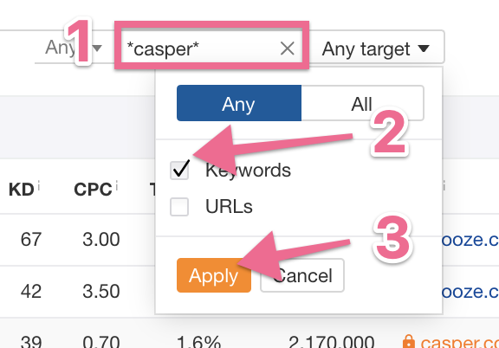

Analyze Your Competitors’ Ads

- Select “Ads” on the sidebar
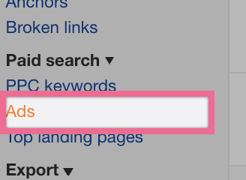

- You will get a list of ads your competitor is currently running:


- To analyze the ads that might be relevant to your business too you will want to remove branded keywords from the list. To do that you will enter your competitor’s name in between asterisks in the ‘Exclude’ > ‘Keyword’ filter.
  - Example: *casper*
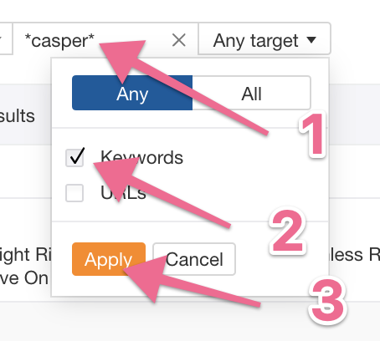

Analyze Your Competitors’ Landing Pages

- Select “Top Landing Pages” on the sidebar
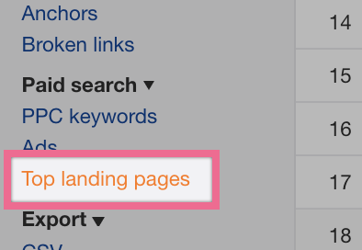

- You will get a list of ads your competitor is currently running:
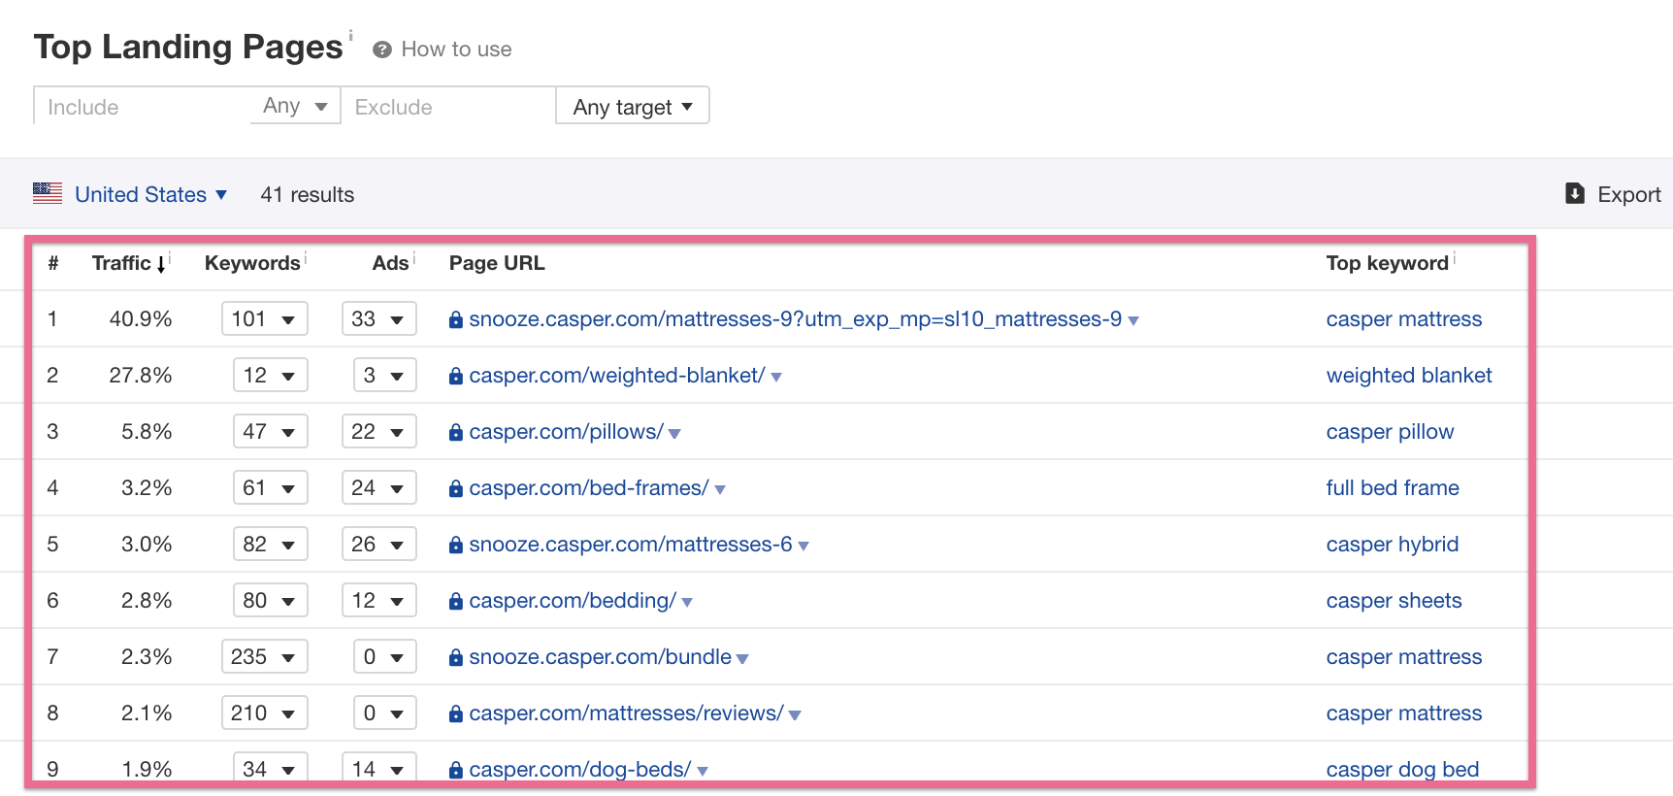

- To analyze the landing pages that might be relevant to your business too you will want to remove branded keywords from the list. To do that you will enter your competitor’s name in between asterisks in the ‘Exclude’ > ‘Keyword’ filter.
  - Example: *casper*


Analyze Your Competitors’ Ad Account Structure

- Grab the list of keywords that you retrieved in the previous section
- For some (or all, depending on how deep you want to go with your analysis), search them yourself in Google in order to try and trigger your competitor’s ads.
  - Important: Make sure you are using an IP address that belongs to the same country you are analyzing in ahrefs.
    - Example: If you are looking at your competitor’s keywords in the US, make sure your IP also belongs to the US.

Note: To check your IP address’ country head over to this website and it will let you know which country your IP Address belongs to.


Note 2: If you want to analyze a country different than the one that your IP address belongs to, your best option is to purchase a VPN service. Just make sure that the VPN service you are purchasing offers servers in the country that you will want to test.

If you don’t know which VPN to pick you can look at VyprVPN, you can check the country list here, to make sure it suits your needs.

- Open an incognito window in Chrome (⌘+⇧+N on Mac, or Ctrl+⇧+N for Windows)
- Head over to the local version of Google according to the country you selected above (the same you are selecting on your VPN).
  - Note: Make sure you type the URL of the country where you want to trigger your competitor’s ads. If you are not sure you can check this table. For example:
    - Google.es - Spain
    - Google.co.uk - United Kingdom
    - Google.com - US
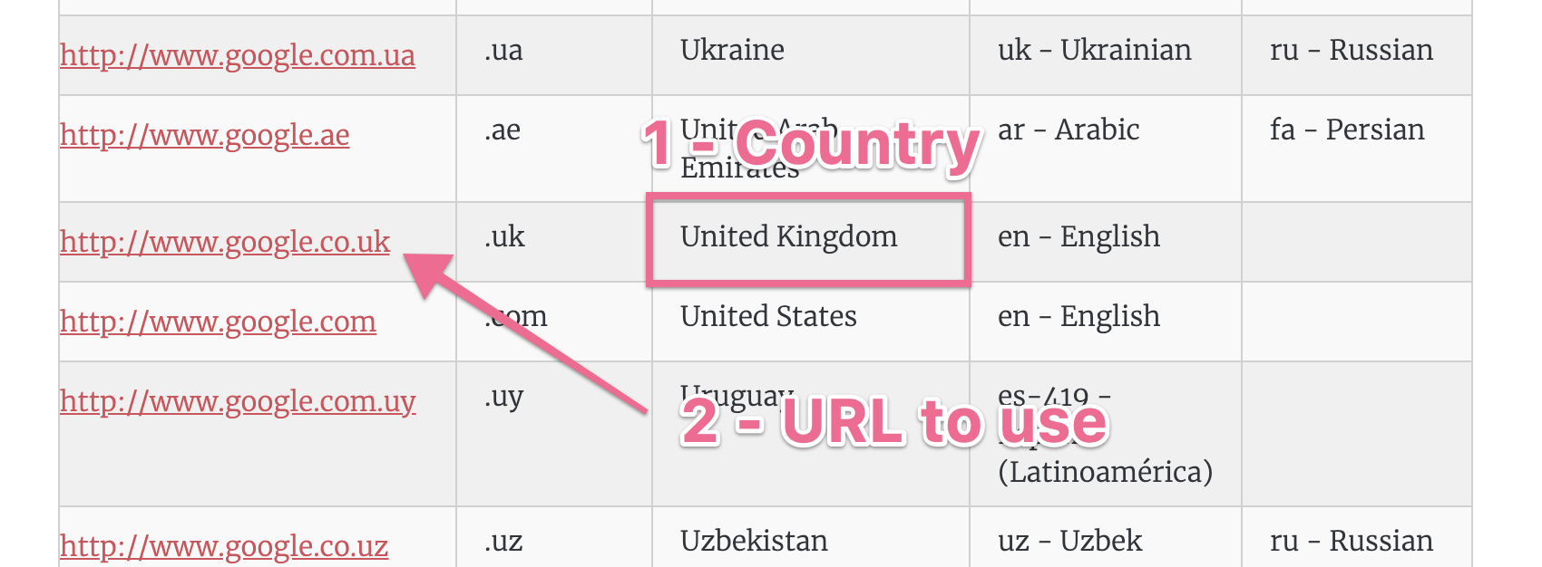

- If everything went well, you will likely see your competitor’s ad show up. Click on the ad.
  - Note: Bear in mind that even if everything was done correctly, in some rare cases you might not get to see your competitor’s ad. If that’s the case you might want to try this procedure a few times and eventually you’ll get served your competitor’s ad.
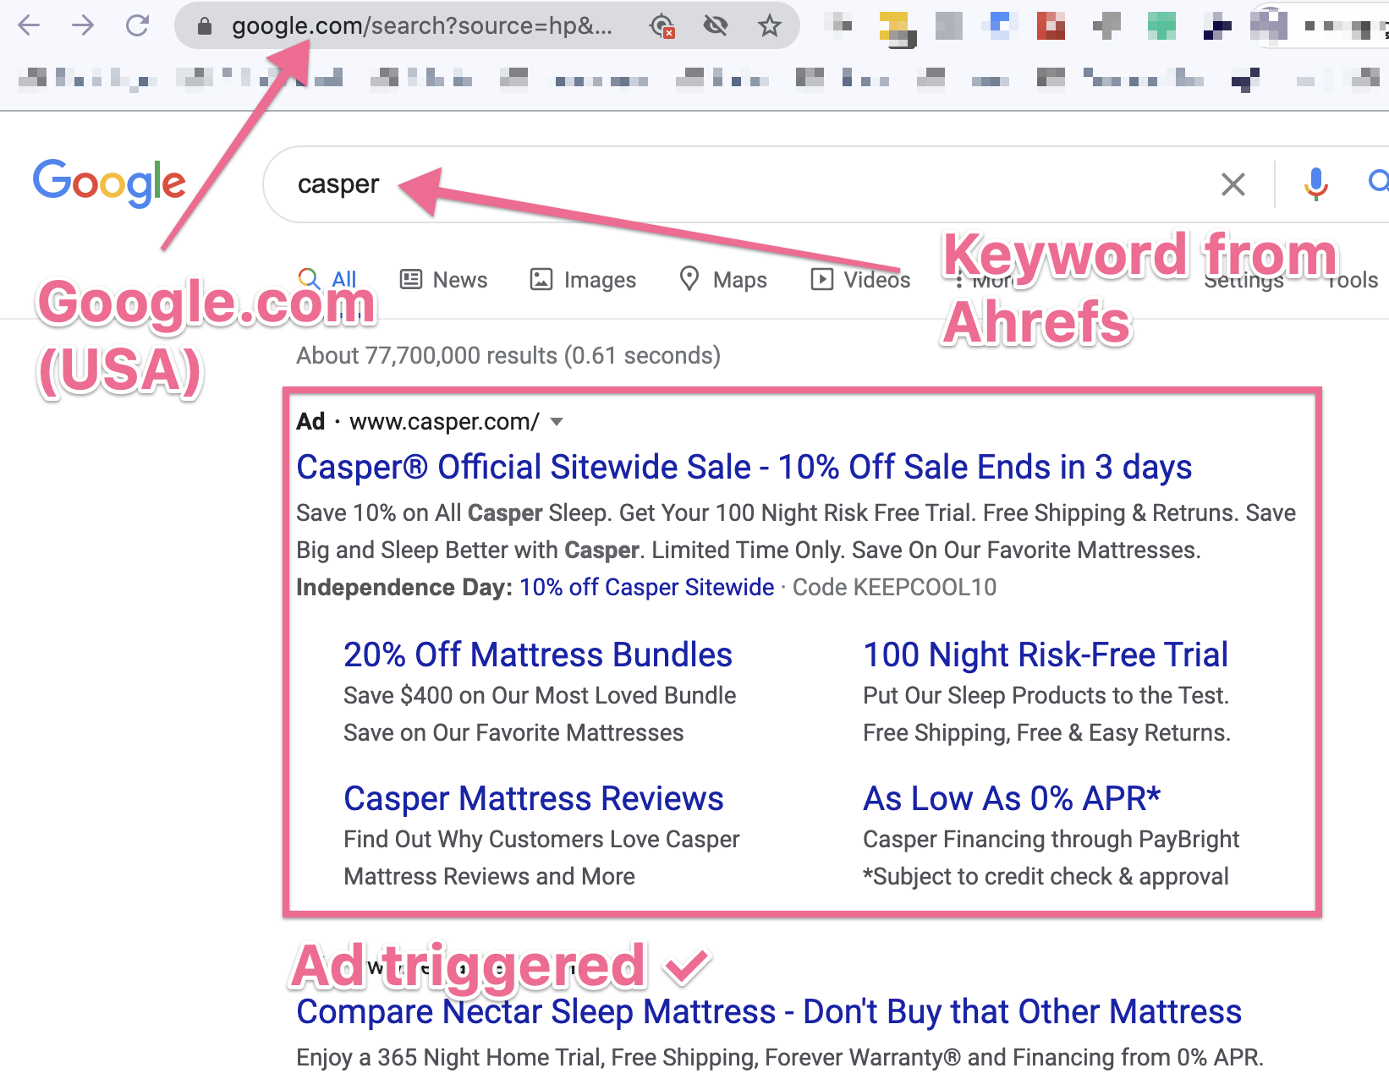

- Check your browser’s URL bar, if your competitor is using UTM parameters, you will be able to see them there:
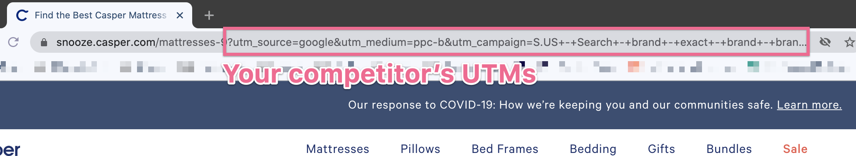
Example:
https://snooze.casper.com/mattresses-9?utm_source=google&utm_medium=ppc-b&utm_campaign=S.US+-+Search+-+brand+-+exact+-+brand+-+brand+-+en+-+ampush

utm_source =google
utm_medium=ppc-b
utm_campaign=S.US+-+Search+-+brand+-+exact+-+brand+-+brand+-+en+-+ampush

- Try to reverse engineer what your competitor’s ad structure based on its UTM parameters, for instance in the example above:

utm_source=google
- Meaning: Traffic is coming from Google
utm_medium=ppc-b
- Meaning: Traffic is coming from PPC (Pay Per Click) and Branded (Guess: b=branded)
utm_campaign=S.US+-+Search+-+brand+-+exact+-+brand+-+brand+-+en+-+ampush
- Meaning: Search US (S.US) // Brand AdSet (Brand) // Exact match (Exact) // English (EN) // Ampush (it’s an an advertising agency, likely the one Casper is using).

- That’s it! Repeat the process for as many times as you need until you have a good overview of the targeting, placements, bidding, and account structure that your competitor is using.

Summarize Your Findings

- Having been through your competitor’s keywords summarize the data you collected:

- Countries: Which countries does your competitor run Google Ads in?
- Branded Keywords: Does your competitor bid on its own brand name?
- Non-Branded Keywords: Does your competitor bid on non-branded keywords?
- Niches: Which topics does your competitor bid in?

Example:
Brand: Casper
Topics: Mattresses, Pillows, Pet Mattresses, Bed Linen, etc

- Having been through your competitor’s ads summarize the data you collected:

- Recurring CTAs: What is it that their ads typically promote?

Example:
Brand: Casper
Ads CTA: Get Your 100 Night Risk-Free Trial

- Ad Extension: Do they use ad extensions? Which ones?

Example:
Brand: Casper
Extensions: Sitelinks, Callouts, Price, etc

- Ad Relevance: Does your competitor have multiple ad copy tailored to the user query?

- Having been through your competitor’s landing pages summarize the data you collected:

- Relevant Landing Pages: Does your competitor have multiple landing pages tailored to different queries?

Example:
Brand: Casper
Landing Pages: Yes, relevant landing pages for different queries (https://casper.com/dog-beds/ - dog beds // https://casper.com/bed-frames/ - bed frames // etc)

- Relevant Offers: Does your competitor have special offers on their ads?

Example:
Brand: Casper
Landing Pages: Yes, they have seasonal offers, and evergreen offers (https://snooze.casper.com/sale - seasonal 4th of July sale // https://casper.com/bundles/ - bundle offer // etc)

- Conversion-focused pages: Are the landing pages optimized for conversions? (i.e: Is there a clear and relevant message, offer, CTA, is it mobile optimized, is it fast loading, etc)

Example:
Brand: Casper
Landing Pages: Yes, pages are fast loading, show relevant products, have clear CTAs, and are mobile optimized.

- Having been through your competitor’s UTMs summarize the data you collected:

- Branded Campaigns/Ad Groups: Does your competitor seem to have independent Ad Groups / Campaigns for branded keywords?

Example:
Brand: Casper
UTM info: Yes, UTMs seem to indicate they might have a branded keyword Ad Group / Campaign (utm_medium=ppc-b // utm_campaign=S.US+-+Search+-+brand+-+exact+-+brand+-+brand)

- Cold Campaigns/Ad Groups: Does your competitor seem to have independent Ad Groups / Campaigns for non-branded keywords?

Example:
Brand: Casper
UTM info: Yes, UTMs seem to indicate they might have a non-branded keyword Ad Group / Campaign

- Regional Campaigns/Ad Groups: Does your competitor seem to have independent Ad Groups / Campaigns for countries, cities, or languages?

Example:
Brand: Casper
UTM info: Yes, UTMs seem to indicate they might have Ad Groups / Campaigns for specific languages and countries. (utm_campaign=S.US+-+Search+-+brand+-+exact+-+brand+-+brand+-+en)

- Funnel-Stage Campaigns/Ad Groups: Does your competitor seem to have independent Ad Groups / Campaigns for different funnel stages?

Note: Usually those will appear in the UTMs as ‘tofu/mofu/bofu, bottom/mid/high, awareness/interest/consideration/purchase, prospecting, or variations of those)

Example:
Brand: Casper
UTM info: Unknown, UTMs don’t seem to tag specific funnel stages, doesn't mean they don’t have it in the account.

- Remarketing Campaigns/Ad Groups: Does your competitor seem to have independent Ad Groups / Campaigns for Remarketing?

Note: Usually those will appear in the UTMs as ‘remarketing, rmkt, R, retargeting, warm, or variations of those).

Example:
Brand: Casper
UTM info: Unknown, UTMs don’t seem to tag specific remarketing audience, doesn't mean they don’t have it in the account.

That’s it! You now have a comprehensive overview of your competitor’s Google Ads strategy.

